## **Resetting the Password in Debian OpenStack Image via GRUB Menu**

### **Download and Import Debian Image**

To reset the password in a Debian OpenStack image, first, download the image from:

[Debian OpenStack Image](https://cdimage.debian.org/images/cloud/OpenStack/current-10/)

The image used in this guide: **debian-10-openstack-amd64.qcow2**

### **Steps to Import the Image into OpenStack:**

1. Open the **Horizon Dashboard**.
2. Navigate to **Project → Compute → Images**.
3. Click **Create Image**.
4. Provide the following details:
   * **Name**: Debian-10-OpenStack
   * **Image Source**: Upload the .qcow2 file
   * **Format**: QCOW2
5. Click **Create Image** to upload it.

### **Launching the Instance**

Once the image is imported, launch an instance using this image:

1. Go to **Project → Compute → Instances**.
2. Click **Launch Instance**.
3. Choose the imported Debian image.
4. Assign a network.
5. Click **Launch**.

### **Accessing GRUB Menu for Password Reset**

If SSH key authentication fails, you can reset the password via the GRUB menu:

1. Open the instance console in OpenStack Horizon.
2. Click on **Send Ctrl+Alt+Del** in the top-right corner.

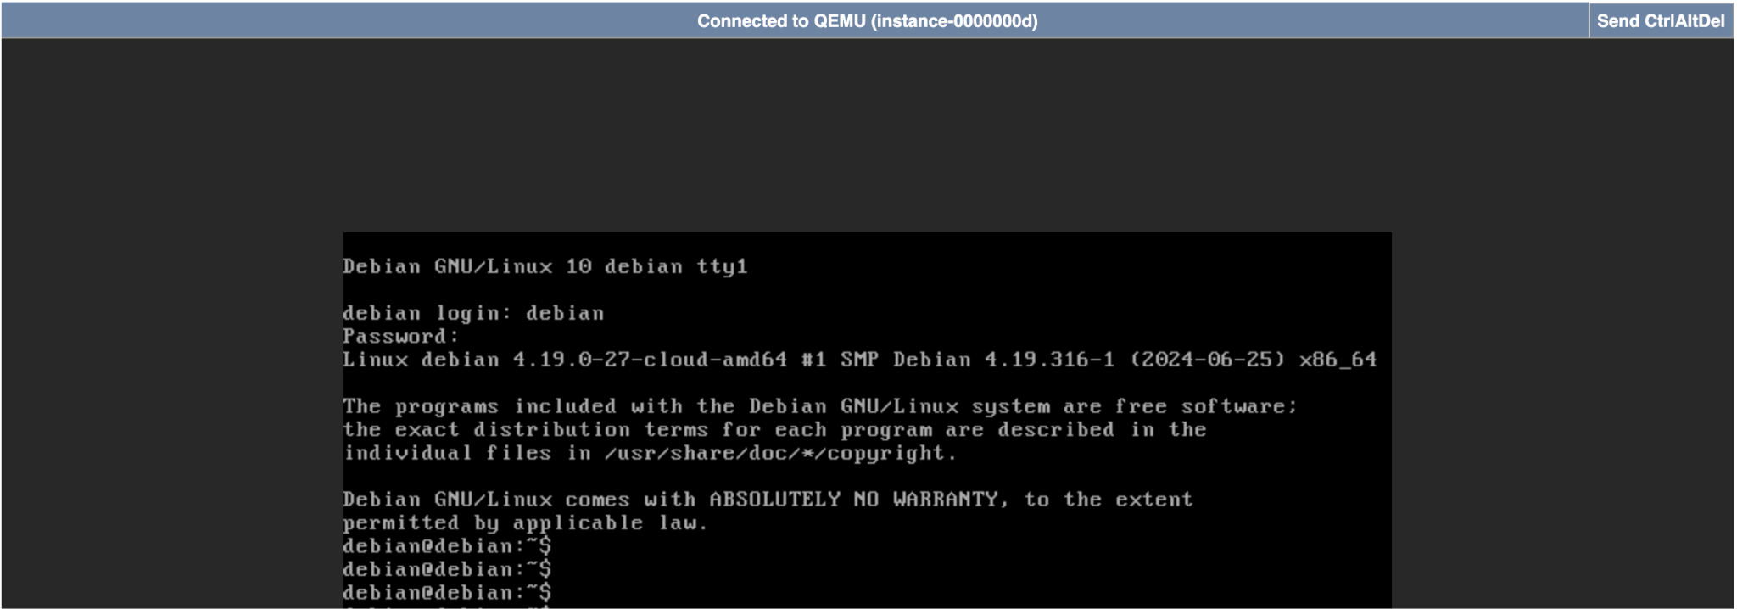

1. The **GRUB boot menu** should appear.

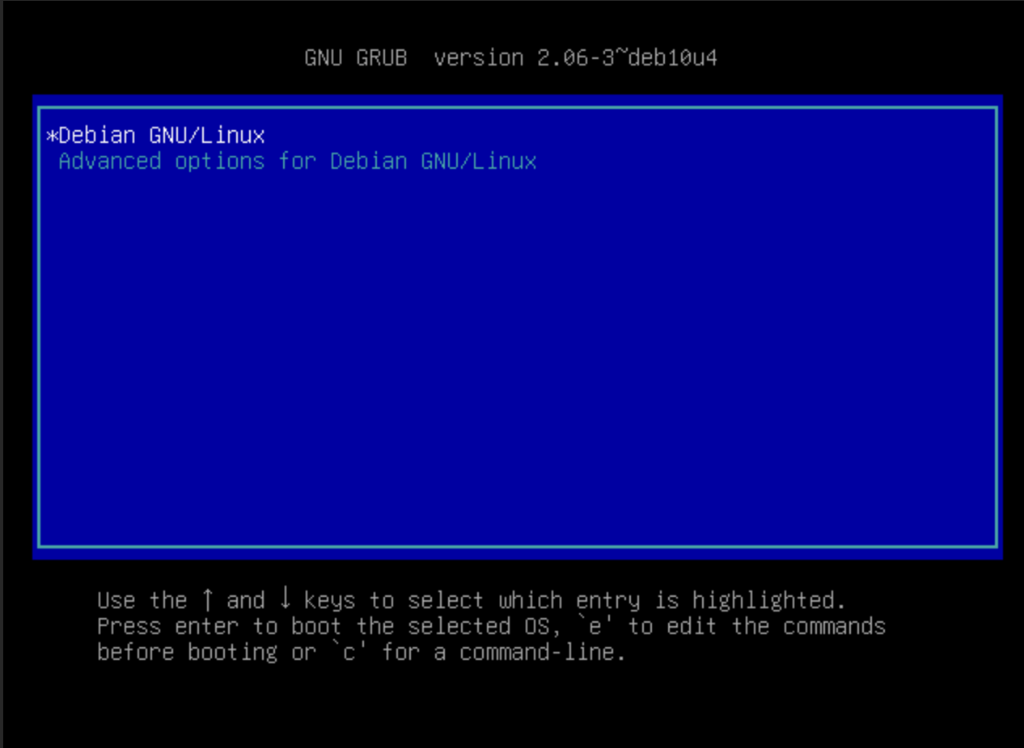

1. With your selection on **Debian GNU/Linux**, press e to edit the boot parameters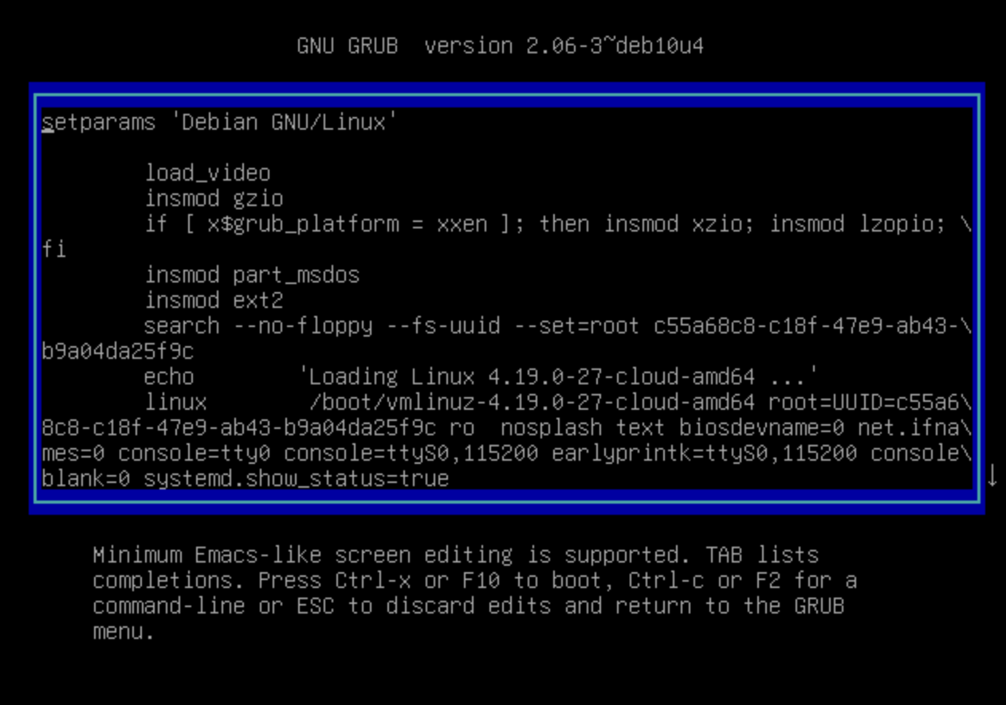
2. Locate the line starting with ***linux***.

6. At the end of this line, add:  
 init=/bin/bash

Your line should look like this:

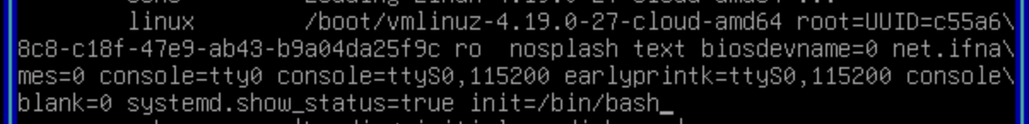

7. Press Ctrl+X to boot into the emergency maintenance shell.

### **Accessing the Instance Console from the Hypervisor**

Since OpenStack's console may not display the emergency shell, access it from your OpenStack server:

Login to your server and list all running instances:  
 sudo virsh list --all

**Example output:**

| Id Name State ----------------------------------- 9 instance-0000000d running |
| --- |

**Connect to the instance console:**

| sudo virsh console <instance-name> |
| --- |

**Example:** sudo virsh console instance-0000000d

Press Enter to get a prompt.

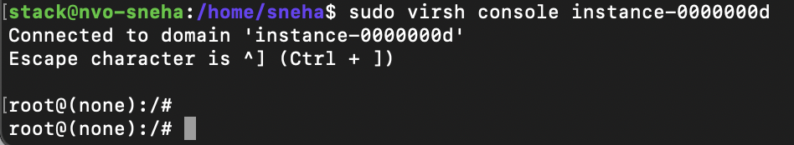

### **Resetting the Password**

Change the password for the debian user:

passwd debian

If you encounter an error like **"Authentication token manipulation error"**, follow these steps:

Check the filesystem mode:

| mount | grep ' / ' |
| --- |

If (ro) appears, it means the filesystem is **read-only** and hence you cannot update the password.



**Remount it as read-write:**

| mount -o remount,rw / |
| --- |

**Verify the remount:**

| mount | grep ' / ' |
| --- |

This is how it should look like



Now, retry the password change

| passwd debian |
| --- |

Something like this:

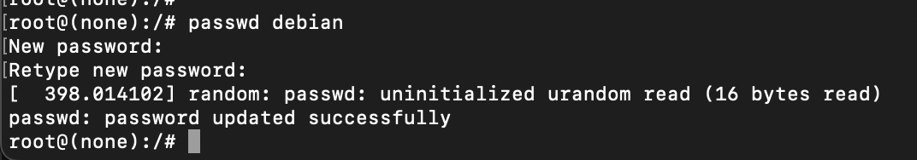

### **Rebooting the System**

If the password change is successful, reboot the system:

| reboot |
| --- |

If you see an error like:

*System has not been booted with systemd as init system (PID 1). Can't operate.*

*Failed to connect to bus: Host is down*

*Failed to talk to init daemon.*

Run the following command to force a reboot:

| reboot -f |
| --- |

### **Logging in with the New Password**

1. Open the OpenStack console.
2. Login using:
   * **Username**: debian
   * **Password**: The new password you just set.

Your Debian instance should now be accessible with the new credentials!